Elastic Collision in One Dimension

We start with the elastic collision of two objects moving along the same line - a one-dimensional problem. An Elastic collision is one that not only conserves momentum, but also conserves internal kinetic energy. Internal kinetic energy is the sum of the kinetic energies of the objects in the system.

Truly elastic collisions can only be achieved with subatomic particles, such as electrons striking nuclei. Macroscopic collisions can be very nearly, but not quite, elastic—some kinetic energy is always converted into other forms of energy, such as heat transfer due to friction and sound. One macroscopic collision that is nearly elastic is that of two steel blocks on ice. Another nearly elastic collision is that between two carts with spring bumpers on an air track. Icy surfaces and air tracks are nearly frictionless, more readily allowing nearly elastic collisions on them.
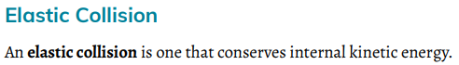



An Example of 1-dimensional elastic collision:
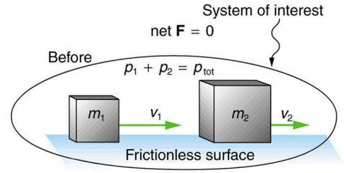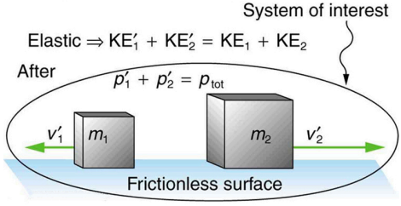
To solve the problem involving 1-dimensional elastic collision, we use the equation of conservation of momentum:
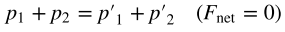
And the equation of conservation of internal kinetic energy:
To form a system of equations to solve what we need.
Example 1.

Elastic Collision: Stationary Target
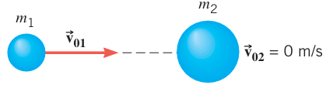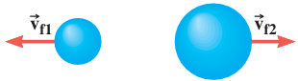
Before Collision After Collision

Practice Problems:
1. A 1055-kg van, stopped at a traffic light, is hit directly in the rear by a 715-kg car traveling with a velocity of 2.25 m/s. Assume that the transmission of the van is in neutral, the brakes are not being applied, and the collision is elastic. What are the final velocities of (a) the car and (b) the van?

2. A cue ball (mass 0.165 kg) is at rest on a frictionless pool table. The ball is hit dead center by a pool stick, which applies an impulse of 1.50 N.s to the ball. The ball then slides along the table and makes an elastic head-on collision with a second ball of equal mass that is initially at rest. Find the velocity of the second ball just after it is struck.
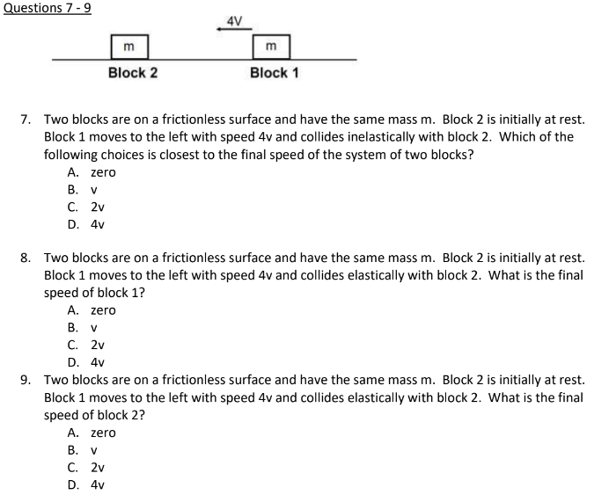
Inelastic Collision in One Dimension
We have seen that in an elastic collision, internal kinetic energy is conserved. An inelastic collision is one in which the internal kinetic energy changes (it is not conserved). This lack of conservation means that the forces between colliding objects may remove or add internal kinetic energy. Work done by internal forces may change the forms of energy within a system. For inelastic collisions, such as when colliding objects stick together, this internal work may transform some internal kinetic energy into heat transfer. Or it may convert stored energy into internal kinetic energy, such as when exploding bolts separate a satellite from its launch vehicle.

Perfectly Inelastic Collision
A collision in which the objects stick together is sometimes called a perfectly inelastic collision because it reduces internal kinetic energy more than does any other type of inelastic collision. In fact, such a collision reduces internal energy to the minimum it can have while still conserving momentum.
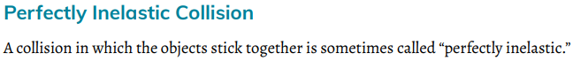
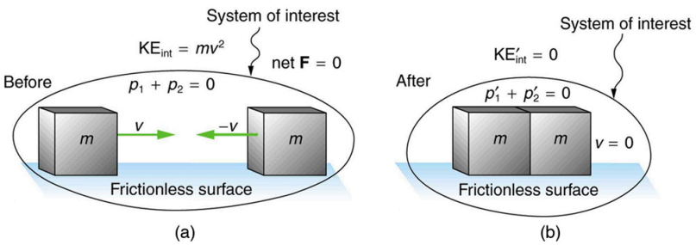
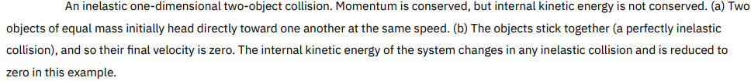
Example 2.
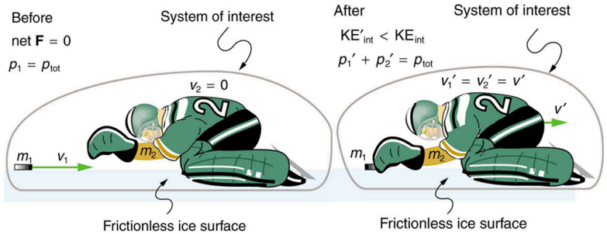

1. An object of mass 3M, moving in the +x direction at the speed $v_{0},$ collides with an object with M moving in the -x direction with speed ${2v}_{0}$. After the collision, the object with mass 3M moves in the -x direction at the speed of $v_{0}/5$ . Calculate the final magnitude and direction of the velocity of the object with the mass M. Determine if the collision was elastic or inelastic, and if it was inelastic, calculate the fraction of the initial kinetic energy dissipated in the collision.

2. A ${1.00×10}^{4}$ kg train car moving due East at 20.0 meters per second collides with and couples to a ${2.00×10}^{4}$kg train car that is initially at rest. (a) What is the common velocity of the 2-car train after the collision? (b) What is the total kinetic energy of the 2-car train before and after the collision?
(c) Is momentum conserved before and after the collision?
(d) Is the kinetic energy conserved? What is the energy loss if energy is not conserved?

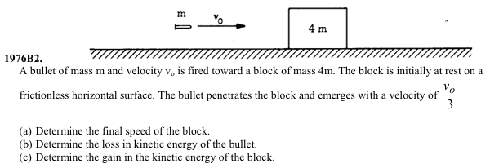

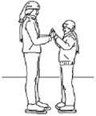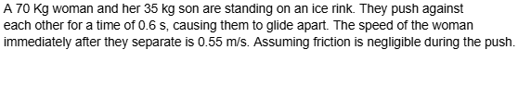
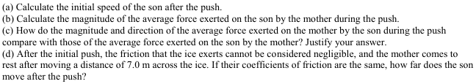

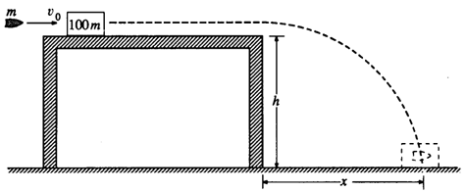
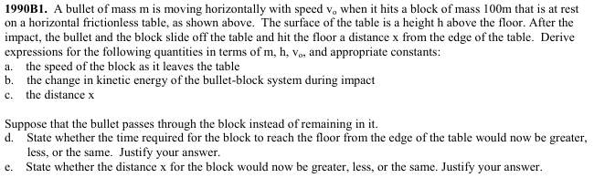

2008B1
